**

[B9IS122 Web and Mobile Applications]

Assessment

2018

|  |  |
| --- | --- |
| Module Title: | Web and Mobile Technologies |
| Module Code: | B8IT061 |
| Module Leader: | John Rowley |
| Assessment Title: | Development of a Progressive Web Application (PWA) |
| Student Number: | 10384363 |
| Student Name: | Harsh Pandloskar |

**Contents**

1. Introduction.…………...…………………………………………………………….………………….…...2
2. Design of Application………………………………………………………………………...…….……...3

(Screen Shots as per requirements for assessment)

1. Learning outcomes…………………………...………………………………………………….…...…...3
2. Conclusion………………………………………………………………………………………………….…...5

**Introduction**

The Assignments Objective is to create a progressive web app that connects to a third-party API and handles offline and online access gracefully and uses local storage to handle off line activities.

The application is Designed and implemented as a Progressive Web Application to use on both desktop and mobile devices that simulates a movie booking application. The first page shows a list of movies which allows for a movie to be chosen. The second page is a movie synopsis page along with movie show time and day. After selecting time and day. It is directed to the third page where the user can select a number of seats in the seat layout section.

**Design of Application**

**Listing all the requirements of the Assessment with screen shots:**

* **Requirement 1 - Contain at least three html pages with appropriate navigation for both desktop and mobile view.**

There are 5 HTML pages :

1. Movie Listing page.

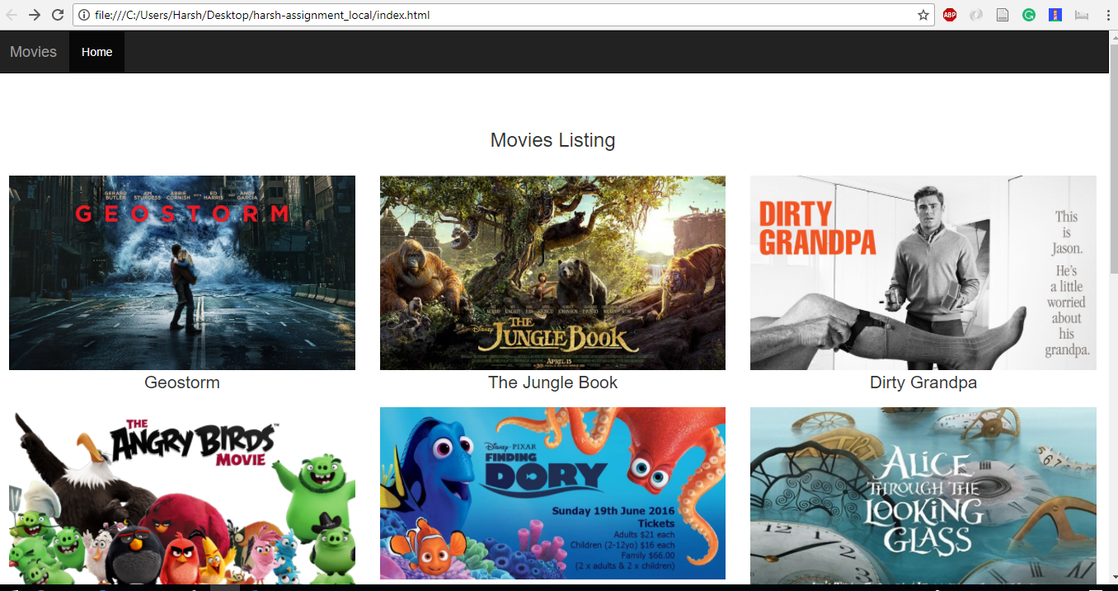

Image : Movie Listing with Header

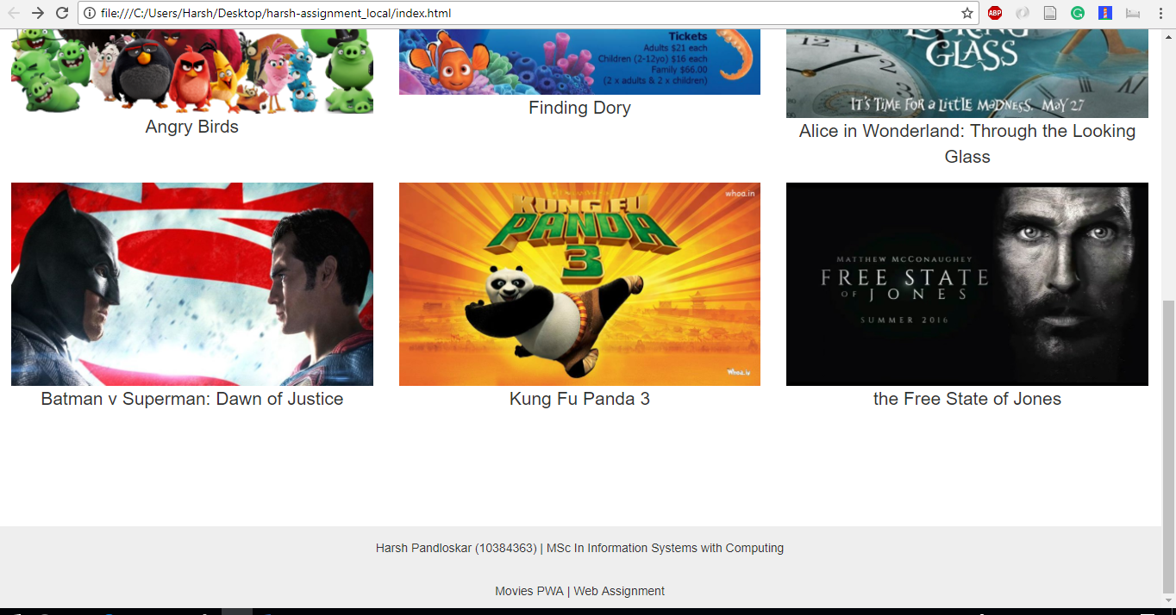

Image: Movie Listing with Footer

1. Movies Synopsis Page with Movie show time and day.

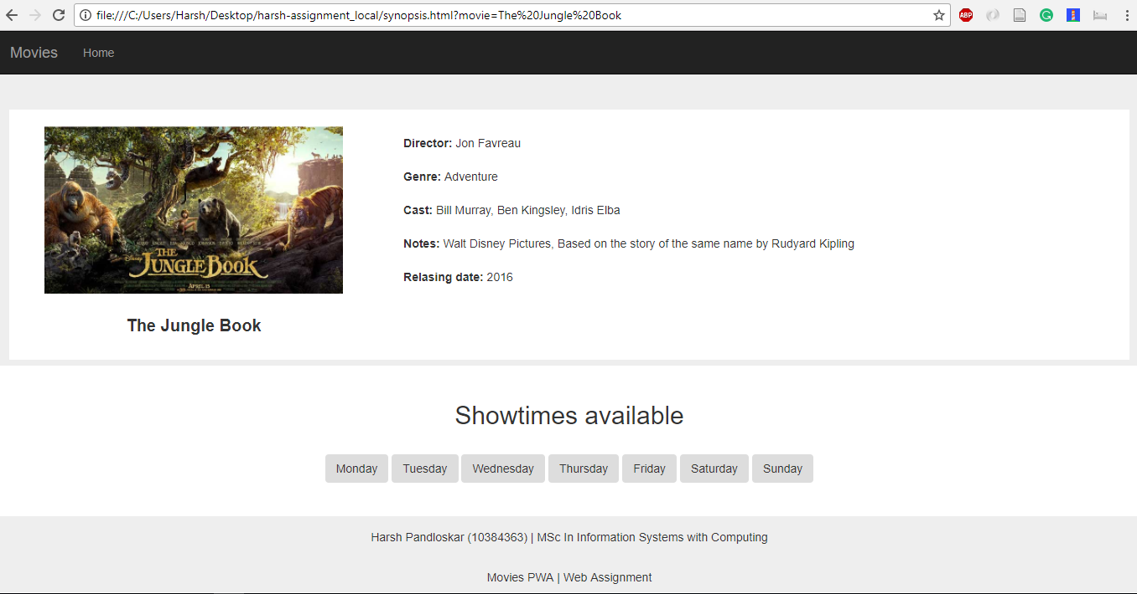

Image: Page Showing Movie Details and bottom part shows days to be selected

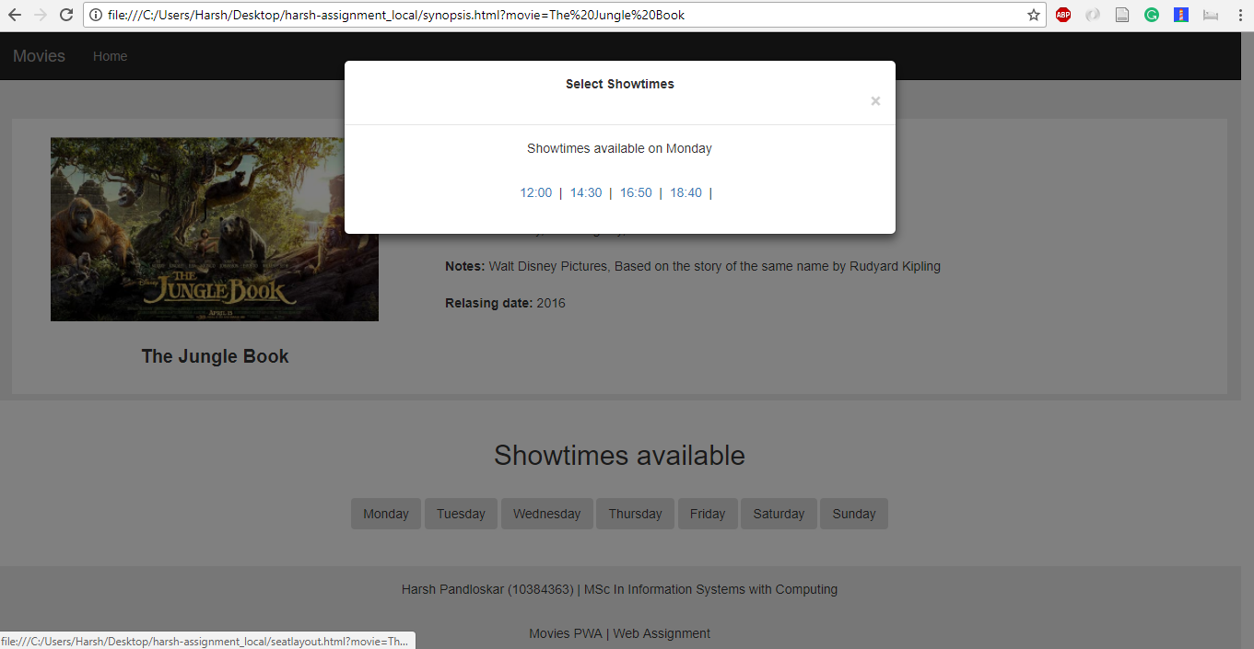

Image: After Selecting a day, A Modal opens up displaying show timings available on the selected day.

1. Seat Selection page.

This is the initial view which includes Selected Movie name, Movie Show time and Day as selected by the User

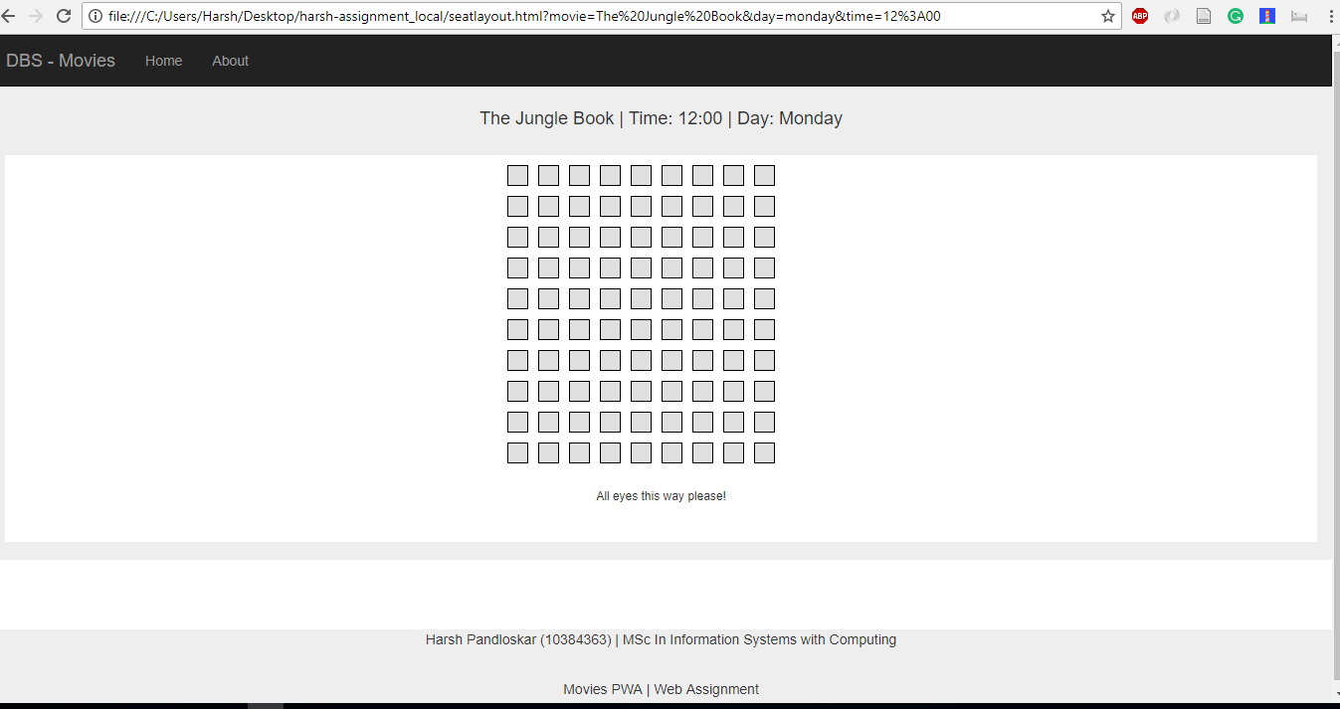

This is a view after the user has selected a seat. A confirm booking button pops out. After clicking this it gets directed to the 4th HTML page i.e. Conformation Page

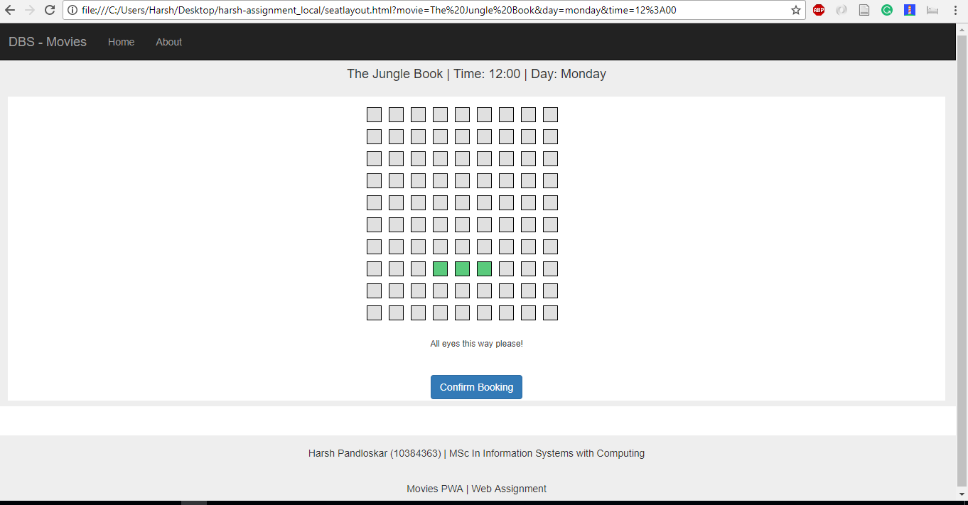

1. Confirmation Page.

This Page shows all the details selected by the user and also a booking ID is provided for every booking

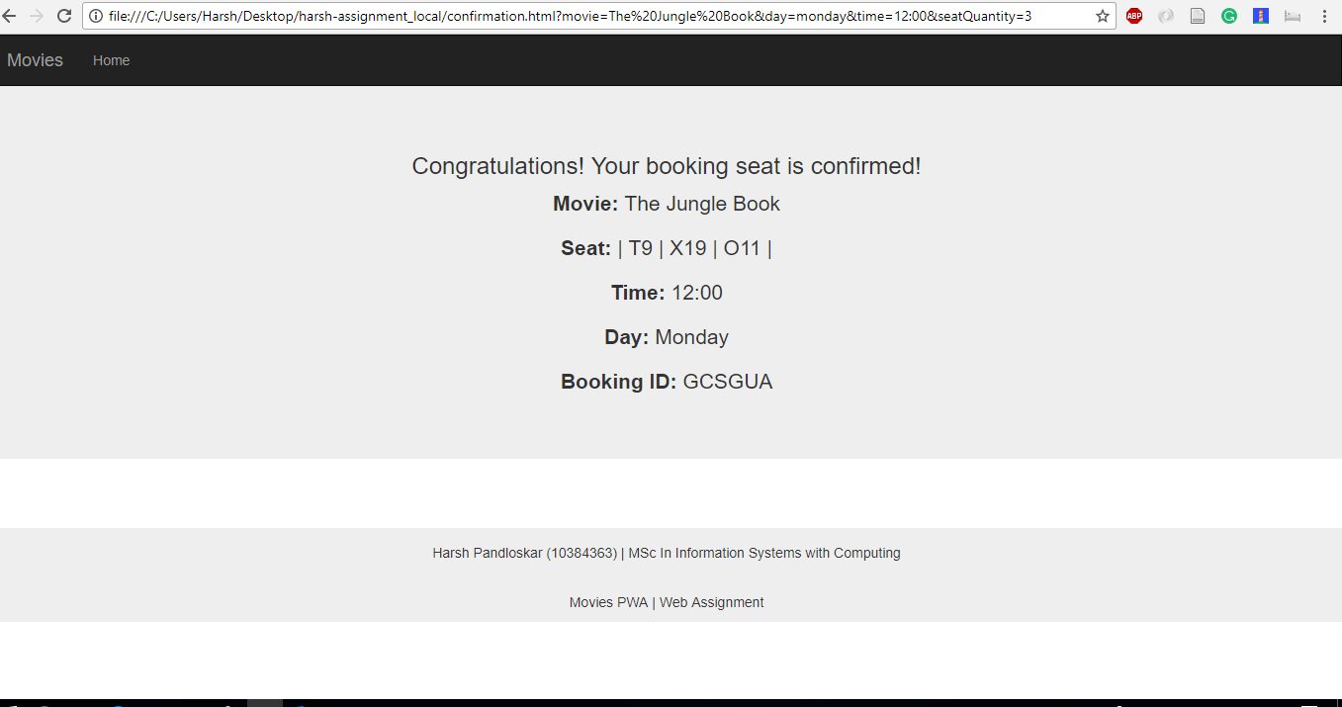

1. 404 error page.

On entering wrong URLs here is an addition page added to this assessment.

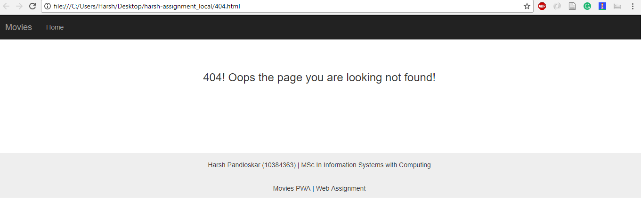

* **Requirement 2 - Contains at least one form.**

Created contact us form

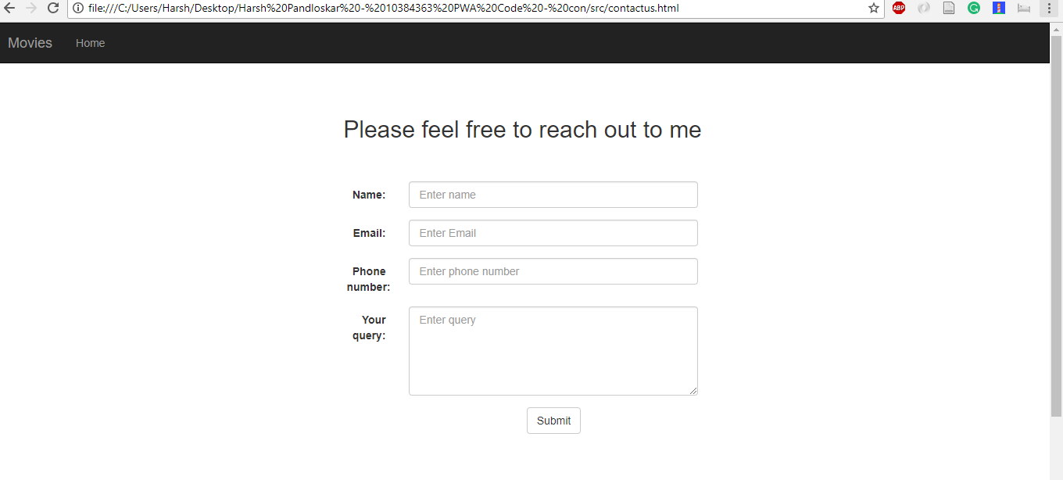

* **Requirement 3 - Connects to the a third-party api for movie listings and displays these in a master / detail view (e.g. movie / movie details)**

Code for getting data from third-party API which is displayed on the Listing page of movies

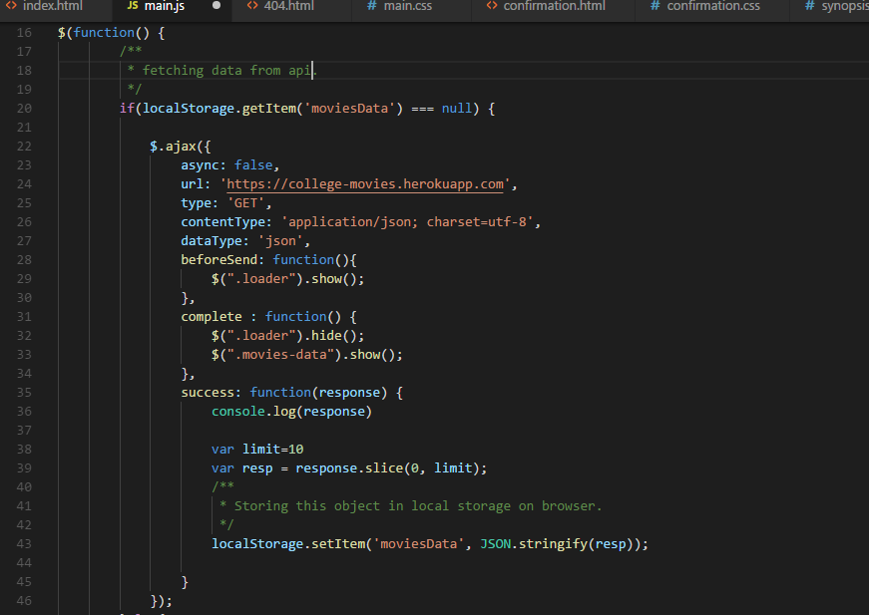

**# Since the Api did not have any image in it, the images were put on cloudinary account and then fetched**

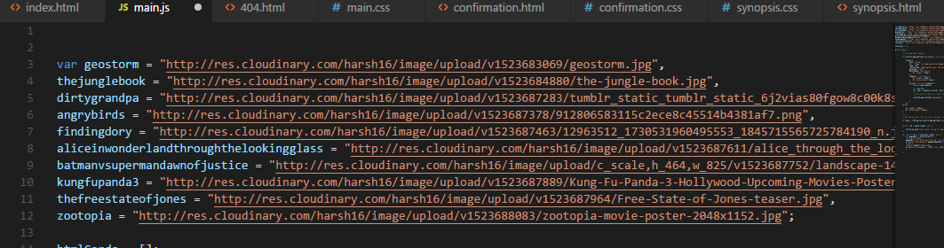

* **Requirement 4 - Displays a list of seats for selection**

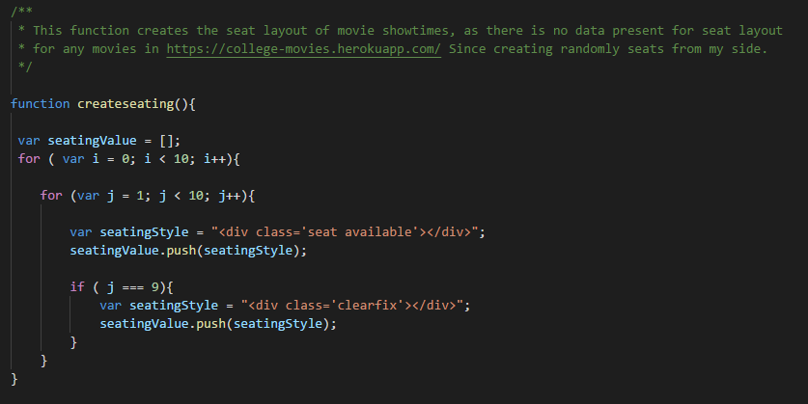

**Code for seat Selection**

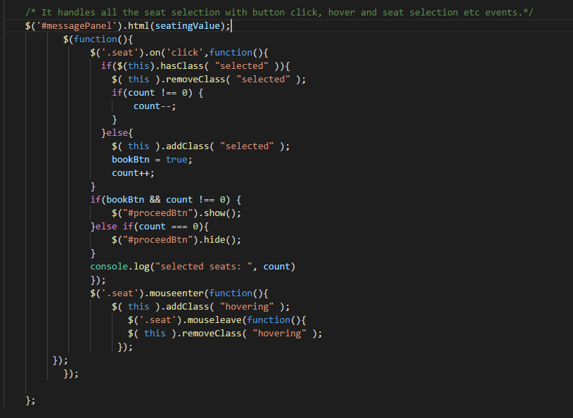

* **Requirement 5 - Uses Bootstrap or another 3rd party CSS framework**

Below is the code and link of bootstrap used

<https://www.w3schools.com/bootstrap/tryit.asp?filename=trybs_temp_portfolio&stacked=h>

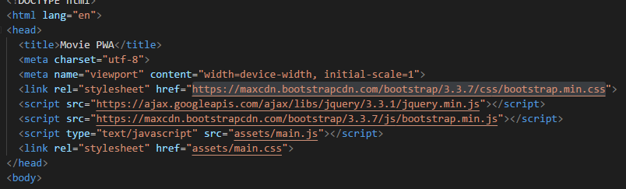

* **Requirement 6 - Use of a media query (device orientation) to restrict a view to landscape**

Below code is used in synopsis page

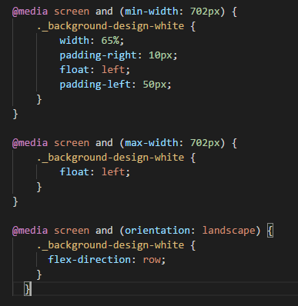 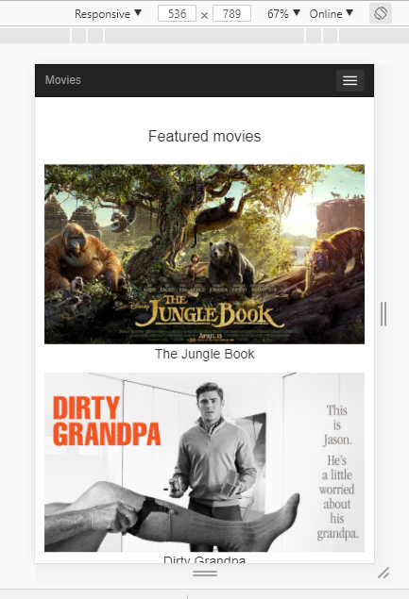

* **Requirement 7 - Using local storage to store at least 5 movies in the event where there is no connection**

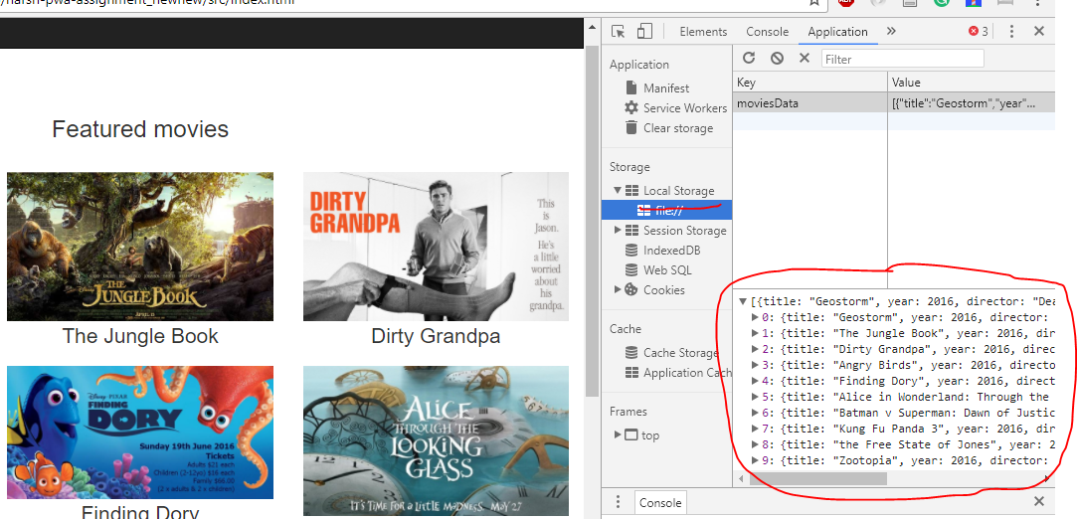

Code to Store Local Data

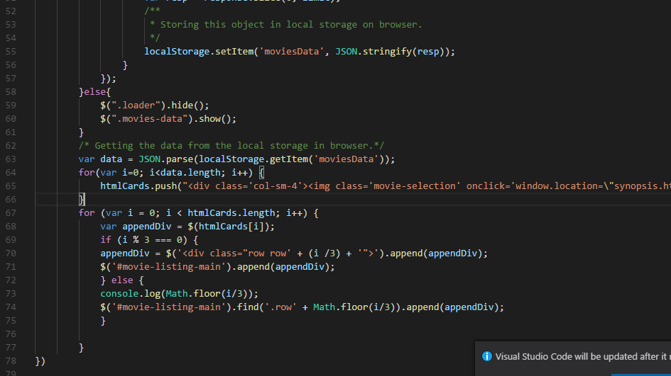

* **Requirement 8 - Service worker to allow for offline usage.**

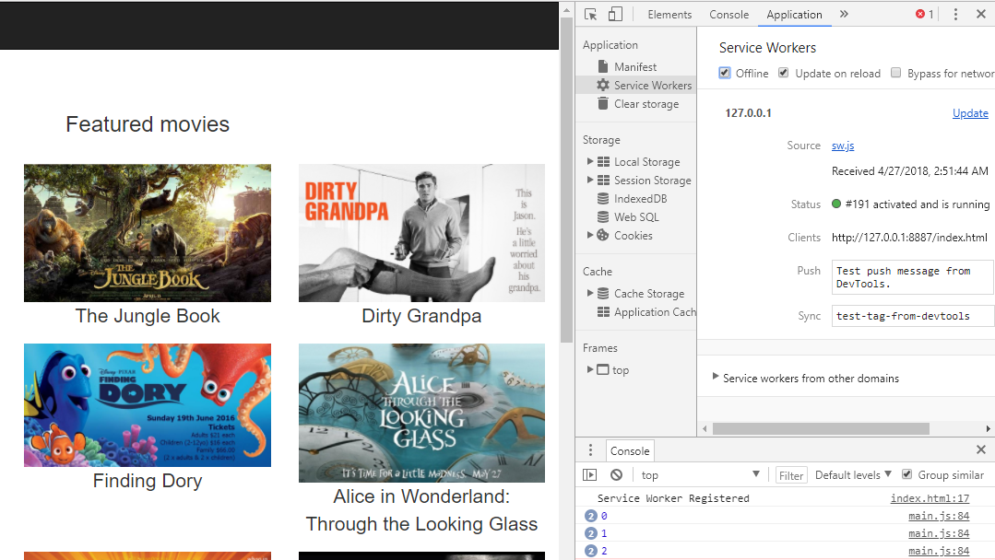

Code for service worker

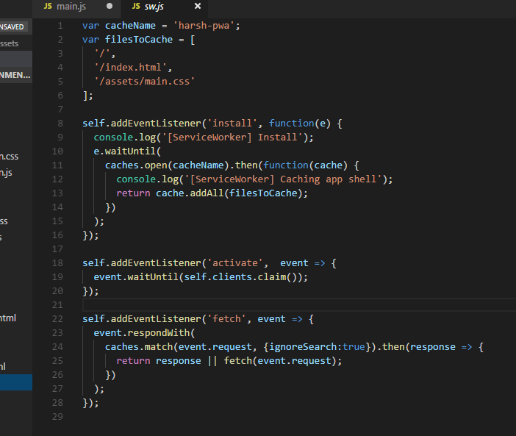

Manifest file

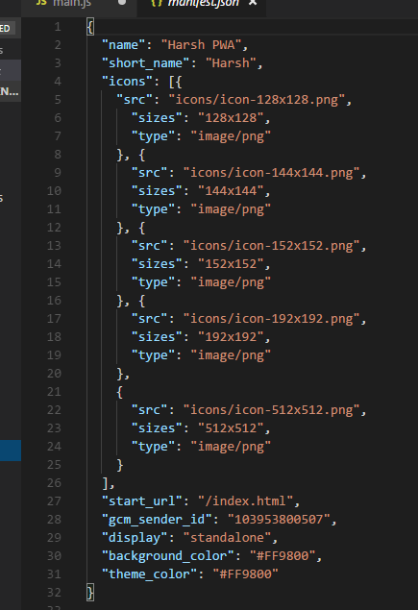

**Learning outcomes**

* Studied how to create a progressive web app.
* Learned how a service worker functions and created a manifest file
* Learned how to connect to a third-party API
* Learned how to handle offline and online access gracefully by making use of local storage to handle offline activities
* Used media query and learned about device orientation to restrict a view to landscape.

**Conclusion**

The assignment is successfully completed with the requirements and the objectives are fulfilled to Develop a Progressive Web Application (PWA) that connects to a third-party API and handles offline and online access gracefully and uses local storage to handle offline activities.